EXPERIMENT – 4

Create a Scrum Project in Jira

AIM
To create a Scrum project in Jira, manage and prioritize product backlog items, plan a one-week sprint, assign tasks, track their progress, and monitor the sprint board from the beginning to the completion of the sprint.

SOFTWARE REQUIRED
- Jira Software (Atlassian)
- Web Browser (Google Chrome / Microsoft Edge)
- Internet Connection

PROCEDURE
Step 1: Create a Scrum Project
- Open Jira Software and log in using your account.
- Click on Projects → Create Project.
- Select the Scrum template.
- Enter the project name as "Library Management System".
- Select the project type and click Create.
Step 2: Create Product Backlog
- Navigate to the Backlog section.
- Click Create Issue to add the required tasks.
- Add at least five backlog items.
- Assign priorities based on the importance of each task.

Product Backlog:
S.No | Backlog Item | Priority | Status
1 | Create User Registration Page | Highest | To Do
2 | Develop API for Login | High | To Do
3 | Design Database Schema | High | To Do
4 | Implement Book Search Functionality | Medium | To Do
5 | Develop Book Issue and Return Module | Medium | To Do
Step 3: Create a Sprint
- Open the Backlog section.
- Click Create Sprint.
- Enter the sprint name as "Sprint 1 – Library Management System".
- Set the sprint duration to one week.
- Set the sprint goal as "Complete the basic functionalities of the Library Management System".
Step 4: Move Backlog Items into Sprint
- Select all five prioritized backlog items.
- Drag and drop the selected items into Sprint 1.
- Verify that all tasks are successfully added to the sprint.
- Click Start Sprint and confirm the sprint details.
Step 5: Monitor Sprint Progress
- Open the Active Sprint board.
- Observe the tasks displayed under three columns: To Do, In Progress, and Done.
- Move tasks from To Do to In Progress when development begins.
- Move completed tasks into the Done column.
- Monitor the sprint progress regularly.
Step 6: Complete the Sprint
- Verify that all assigned tasks have been completed.
- Move the completed tasks into the Done column.
- Click Complete Sprint.
- Review the sprint summary and progress report.

Output
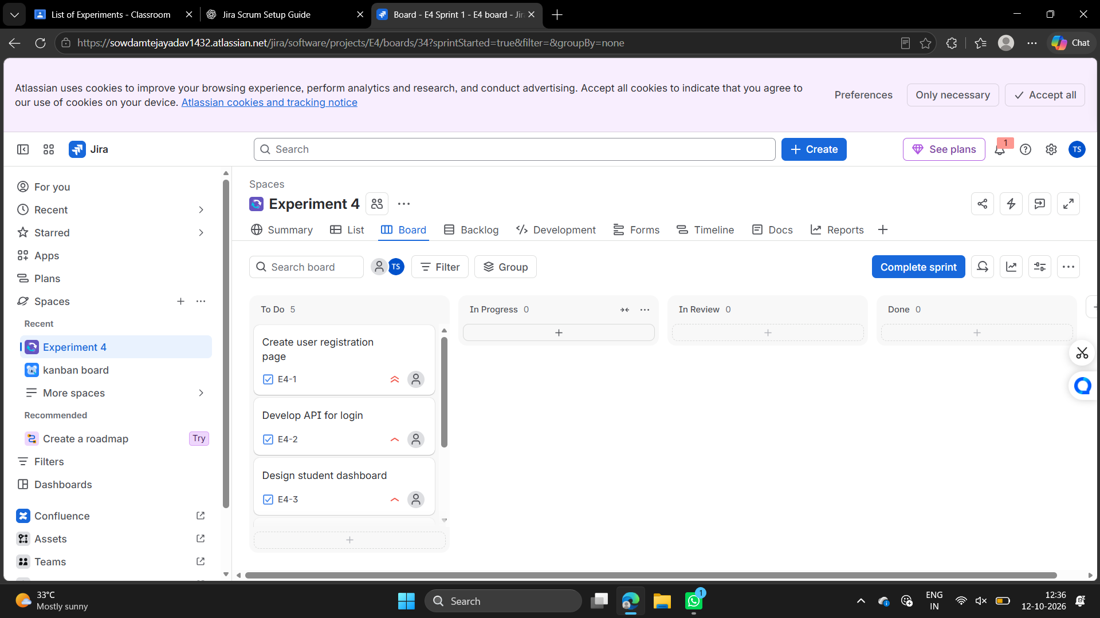

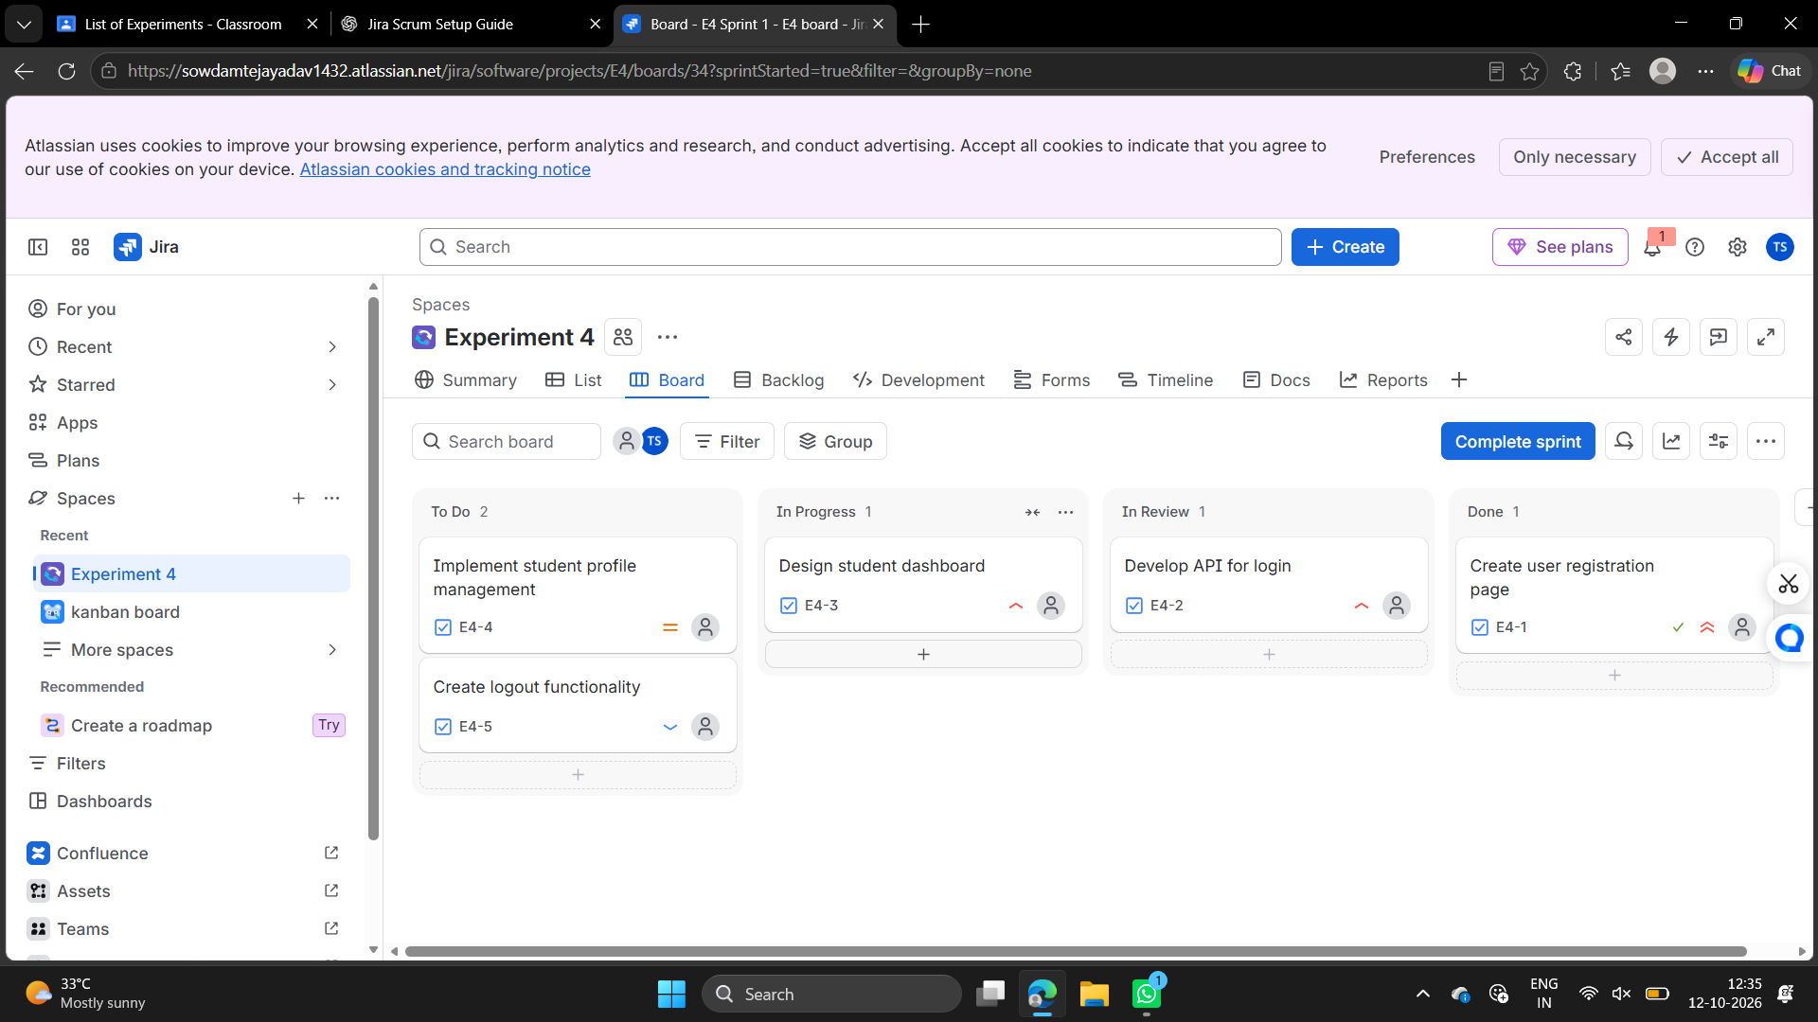
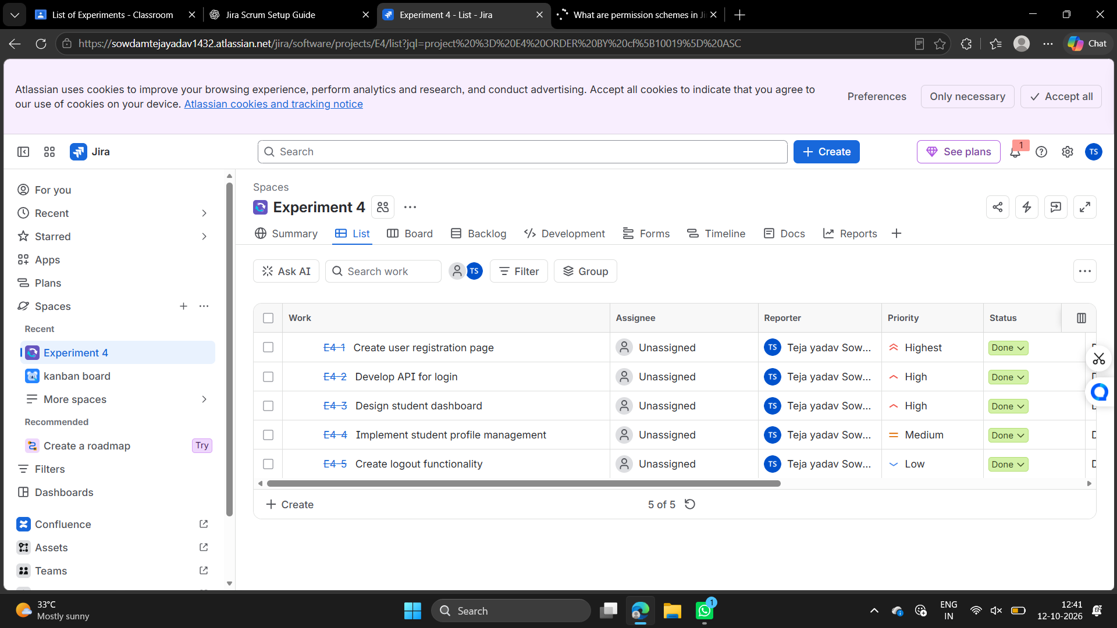

RESULT
The Scrum project for the Library Management System was successfully created in Jira. Five backlog items were added and prioritized based on their importance. A one-week sprint was created, and the selected backlog items were moved into the sprint. The progress of tasks was monitored using the Scrum board, and the initial and final sprint board screenshots were captured.

